SEMESTER TWO
Papers written by
Australian Maths Software

YEAR 12
MATHEMATICS METHODS
Units 3-4
REVISION 3
2016
Section Two
(Calculator–assumed)
Name: _________________________________

Teacher: ________________________________

TIME ALLOWED FOR THIS SECTION

Reading time before commencing work: 10 minutes
Working time for section: 100 minutes

MATERIAL REQUIRED / RECOMMENDED FOR THIS SECTION

To be provided by the candidate
Standard items: pens, pencils, pencil sharpener, highlighter, eraser, ruler.

Special items: drawing instruments, templates, notes on up to two unfolded sheet of A4 paper, and up to three calculators approved for use in the WACE examinations.

IMPORTANT NOTE TO CANDIDATES

No other items may be taken into the examination room. It is your responsibility to ensure that you do not have any unauthorised notes or other items of a non–personal nature in the examination room. If you have any unauthorised material with you, hand it to the supervisor before reading any further.

To be provided by the supervisor

Question/answer booklet for Section Two.
Formula sheet retained from Section One.
Structure of this examination

 | Number of questions available | Number of questions to be answered | Working time (minutes) | Marks available | Percentage of exam
Section One  Calculator—free | 5 | 5 | 50 | 50 | 35
Section Two  Calculator—assumed | 13 | 13 | 100 | 100 | 65
Total marks |  |  |  | 150 | 100

Instructions to candidates

1. The rules for the conduct of this examination are detailed in the Information Handbook.
Sitting this examination implies that you agree to abide by these rules.

2. Write your answers in the Question/Answer booklet.

3. You must be careful to confine your responses to the specific questions asked and to
follow any instructions that are specific to a particular question.

4. Spare pages are provided at the end of this booklet. If you need to use them, indicate
in the original answer space where the answer is continued i.e. give the page number.

5. Show all your working clearly. Your working should be in sufficient detail to allow your answers to be checked readily and for marks to be awarded for reasoning. Incorrect answers given without supporting reasoning cannot be allocated any marks. For any question or part question worth more than two marks, valid working or justification is required to receive full marks. If you repeat an answer to any question, ensure that you cancel the answer you do not wish to have marked.

6. It is recommended that you do not use pencil, except in diagrams.

7. The Formula Sheet is not to be handed in with your Question/Answer booklet.

6. (4 marks)
(a) The equation of the graphed function is 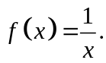
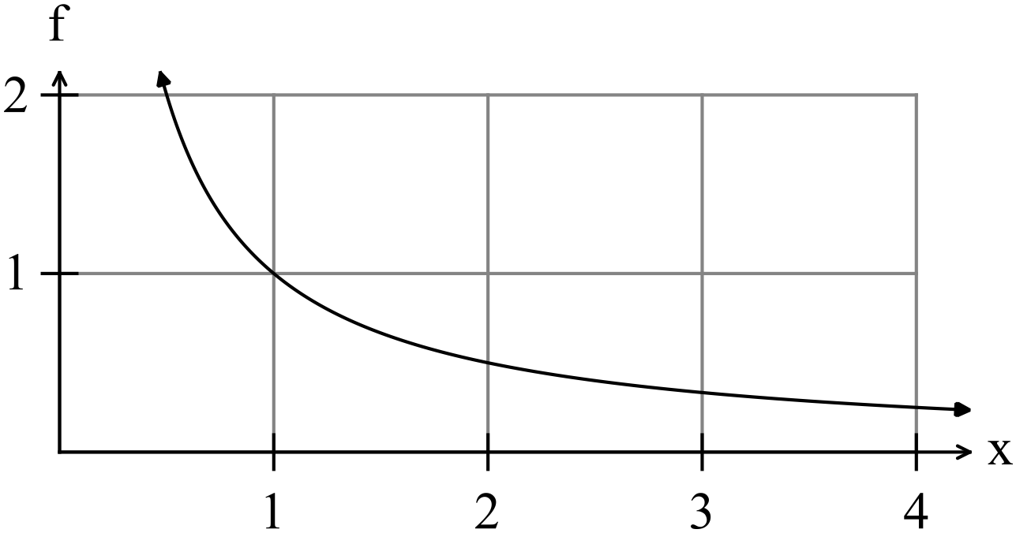

Determine the area between the function, the axis for 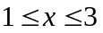 correct to three decimal places. (2)

(b) The function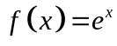 graphed below.
Find the expression for the area between the line and the function .
(2)
NB You do not have to calculate the area.

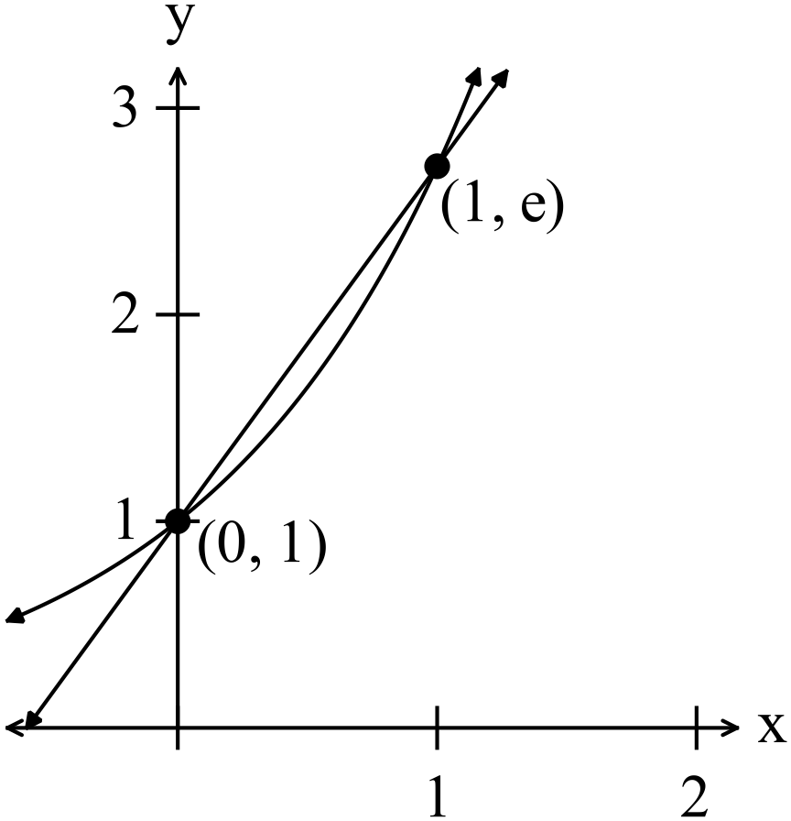

7. (10 marks)

(a) The function 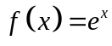 is sketched on the set of axes below.

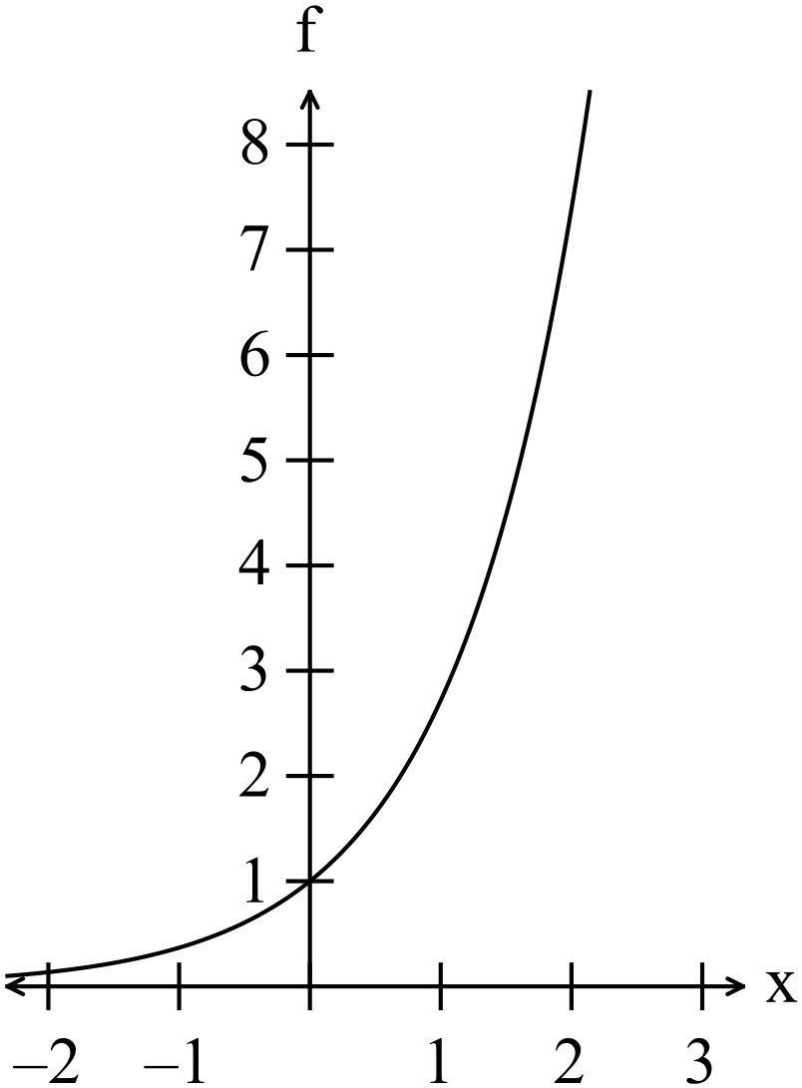

(i) Write down the derivatives 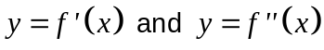. (1)

(ii) Discuss fully the relationship between the functions 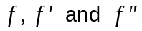.
In your discussion you should mention turning points, points of inflection,
concavity, gradient, and how they relate to the functionand its graph. (3)

(b) (i) Sketch a function that has the following properties

x | -2 | 0 | 2
f | 16 | 0 | -16
f ’ | 0 | -12 | 0
f ‘’ | - | 0 | +
(3)

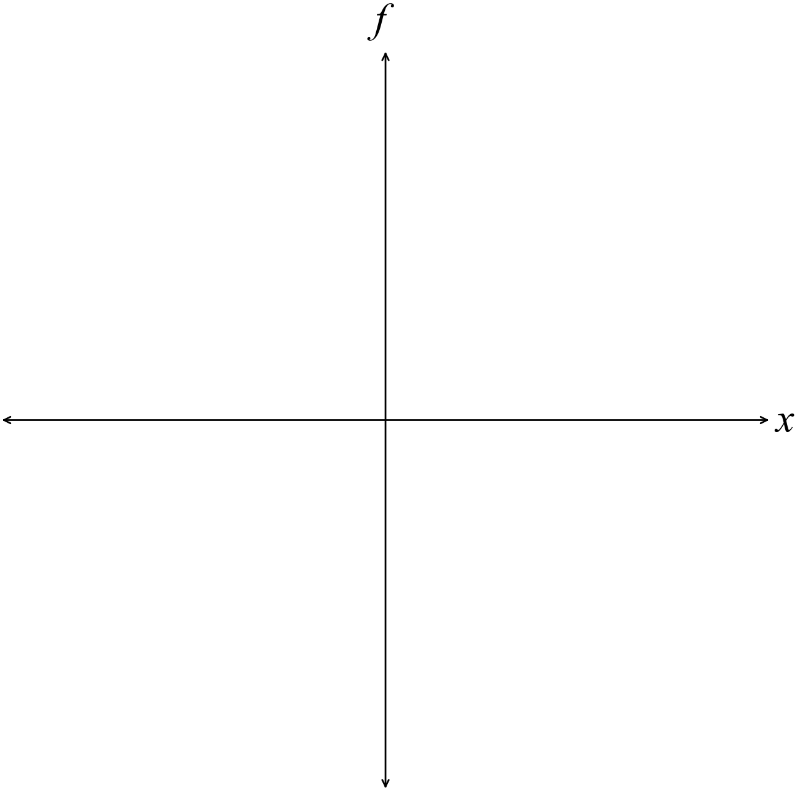

(ii) Write down the equation of the function. (3)
8. (6 marks)
The volume of a sphere is 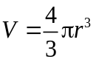. Use a calculus method to determine the
increase in the volume if the radius increases from 1 to 1.05 metres. (4)

(b) Use your calculator to evaluate 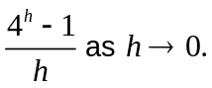 (2)
9. (5 marks)
(a) Find 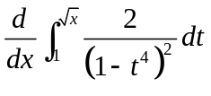 (3)

(b) (i) If 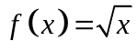 find 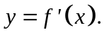 (1)

(ii) Hence find 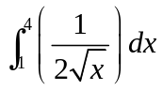 (1)

10. (6 marks)

The 2014-15 National Health Survey found that 23% of Australian aged 18 and over
had hypertension (high blood pressure). For those aged 75 and over, 46.9% had
hypertension.
Assume the percentage, , of those with high blood pressure rises exponentially
i.e. according to the law 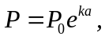 where represents age.
(a) Find the relationship between the percentage of people with hypertension and
age. (4)

(b) What percentage of people had high blood pressure at age 70? (2)

NB Professor Markus Schlaich of Perth conducted trials with a new procedure to combat high blood pressure in March 2016.
11. (6 marks)

The displacement of a particle is given by 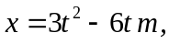where is measured in
seconds, determine
(a) the displacement when the particle changes direction. (2)

(b) the acceleration at 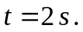 (1)

(c) the distance travelled during the first ten seconds. (3)

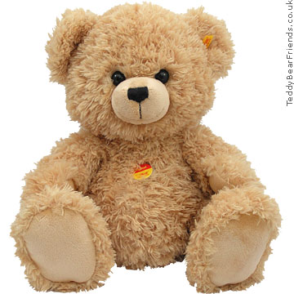
12. (8 marks)

(a) A toy teddy bear waves its arms up and down.
The motion of the arms is modelled on the equation
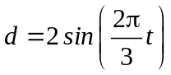 where is measured in seconds and in cm.
(i) How far up and down do the teddy bear’s arms move? (1)

(ii) How long does a complete wave of the teddy bear arms take? (1)

(iii) If the teddy bear’s arms started to move twice as fast, write down the
equation that models the faster motion. (2)

(b) A vat is slowly being filled with whisky. The volume of the whiskey in the vat
follows the rule 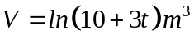 from 9 a.m. when .

(i) Find the volume of whiskey in the vat at 11 a.m. (2)

(ii) When will the vat be filled to 3 m³? (2)

13. (7 marks)

A cone is inscribed in a sphere of radius 2.

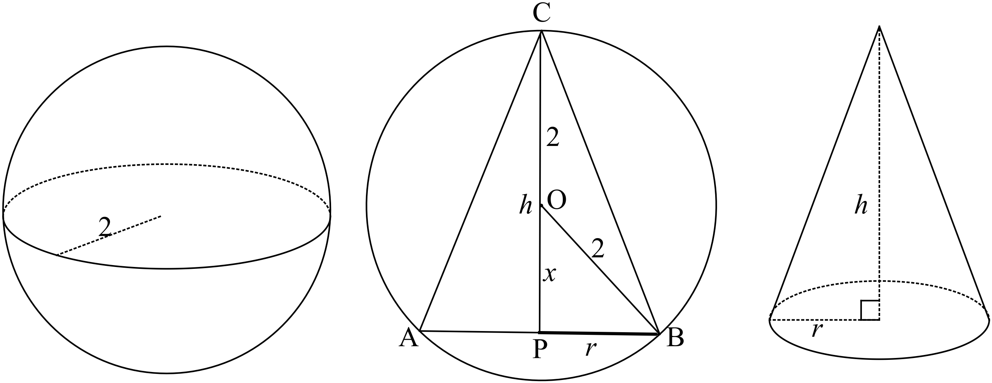
(a) Find an expression for the volume of the cone in terms of (2)

(b) Explain precisely what you would need to do to determine to find the dimensions
of the cone of maximum volume which can be inscribed in the sphere. (5)
NB You do not have to solve the problem.
14. (12 marks)
(a) Two spinners as shown below are spun simultaneously.

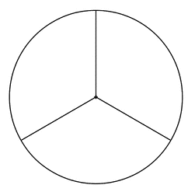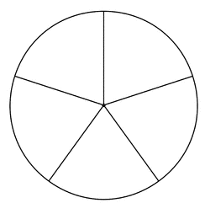
1
1
2
2
3
3
4
5
The numbers the spinners land on are added. The possible combinations are shown in the table below.

 |  | Spinner of side 5
 |  | 1 | 2 | 3 | 4 | 5
 | 1 | 2 | 3 | 4 | 5 | 6
Spinner of side 3 | 2 | 3 | 4 | 5 | 6 | 7
 | 3 | 4 | 5 | 6 | 7 | 8

(i) Complete the following probability density table. (3)
Score when added | 2 | 3 | 4 | 5 | 6 | 7 | 8
P(score)

(ii) Find P(the score is odd) (1)

(iii) Find P(there is at least one odd number) (1)

(iv) Find P(a score of 6 or 7) (1)

(b) Find the mean and variance of the probability density function in (a). (4)

(c) Which of the following are not probability density functions?
State clearly why.

(i)
 | 1 | 2 | 3
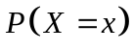 | 0.3 | 0.4 | 0.5

(1)

(ii)
 | 3 | 4 | 5
 | 0.6 | - 0.1 | 0.3

(1)

15. (8 marks)
The weight of a piece of steak in Fred’s favourite restaurant is advertised as at least 280 grams.
The weight of steaks actually served are normally distributed with a mean of 300 grams with a standard deviation of 10 grams.

Fred is fussy about his steaks.

(a) What is the probability that Fred is served a steak under the advertised weight?
(2)

(b) Given that Fred’s steak was not below the advertised weight, what are the
chances it was at least 300 grams? (3)

One week Fred took three of his friends and they all had steak.
(c) What is the probability that at least three of the men had steaks greater
than 300 grams?
(3)

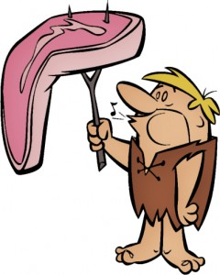
16. (6 marks)
Consider the probability density function 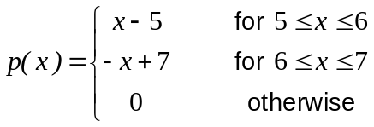
graphed below.
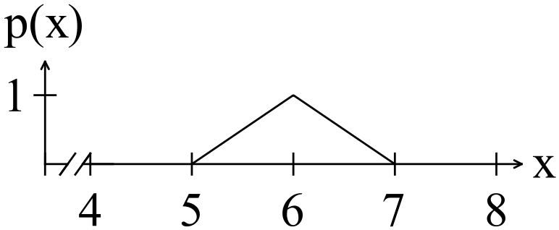

(a) Find 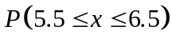 (2)

(b) Find the mean and the variance of the distribution. (4)

17. (8 marks)
The probability that the baker runs out of sultana buns by the time Bill leaves work is
about 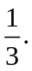 Bill calls in every Monday to buy a sultana bun on his way to night class.
What is the probability that
(a) on the next 6 Mondays Bill manages to buy a sultana bun each time? (2)

(b) on the next 6 Mondays Bill only manages to buy a sultana bun 4 times out of 6?
(2)

(c) Bill can buy a sultana bun if on the last three Mondays the shop had run out of
buns. (2)

(d) on the next six Mondays Bill is able to buy a sultana bun only on alternate
Mondays?
(2)

18. (14 marks)
(a) The probability of an Australian lady over 40 years of age not having had
children is 0.1.
In a sample of 60 ladies over 40, what are the chances that between 5 and 9 of them have had no children? (4)

(b) Eighty five out of 100 people surveyed by Stirling Council wanted garden rubbish
collected more than once a year.

(i) Determine an estimate for the probability that the people in the Council
area wanted garden rubbish collected more than once a year. (1)

(ii) Determine the 90% confidence level the probability that the people in the
Council area wanted garden rubbish collected more than once a year. (4)

(c) Residents living in East Perth are thought to want no more high rise
developments. It was planned to conduct a survey to determine the proportion of
residents that object to more high rise development.

How large should the sample be, allowing for an error margin of 10% with a 95%
confidence level? (5)

